

Bank Management System

Project Done by:
Aneez Ahmed Jaheez
Srivatsan T.V
Acknowledgement

The acknowledgement is the most beautiful page of any book.

I, Aneez Ahmed Jaheezuddin of class XII, find words quite inadequate to express my gratitude to many people. First and foremost, I would like to thank the Almighty. I would also like to express my gratitude to the Principal of my school, Mrs. Stella Punitha and the Campus Head, Mrs. Nancy James for their constant encouragement and support.

I would like to specially thank my computer science teacher, Mrs. Lovely Binesh, for making my practical sessions both enjoyable and informative which provoked my inquisitiveness and curiosity throughout the academic year 2018-19.

I would also like to thank my parents and friends for their continued help and support, without which I would not have been able to complete this project with such success.

Thank you very much.

INDEX

S.NO | TOPIC | PAGE NO.
1. | Aim | 3
2. | Synopsis | 3
3. | Advantages of the Proposed System | 4
4. | Uses of the Proposed System | 4
5. | Why this project? | 4
6. | System requirements | 5
7. | System Flow Diagram | 6
8. | Header Files and User-Defined Data | 9
9. | Algorithm | 12
10. | Source Code | 16
11. | Screenshots | 30
12. | Scope of Improvement | 35
13. | Bibliography | 36

Aim:

The aim of the Bank Management System software is design a system through which a bank administrator can manage customer information , stock details, purchase details, etc.

Synopsis:

The objective of this study is to make the customers of various banks do their account accessibility and transactions using the solution proposed in the following statement. Customers need not interact with various applications or websites of each bank. The admin will have full control over bank details and can update the existing details of the customer and the bank. The admin will handle the registration of a customer to use this application. The bank admin can access the application to see all customer account details and he/she can accept or reject the fund transfer of the customer. The admin should be able to provide response for the queries the customer puts forward. The customer should also be able to view the account related details through the admin. The customer should also be able to send queries to the bank admin.

Every day banks need to perform many activities which requires developed infrastructure and more staff members. But the online banking system allows the banks to perform these activities in a simpler way without involving the employees, for instance, online banking, mobile banking and ATM banking. Additionally the banking needs more security. Moreover, all the transactions are manual work, so this results in time delays. In this system, the user can easily perform the money transaction at any time, and from any place. Each and every transaction is sent to the user via message. There are two main modules called admin and user modules. In the admin module, the admin can maintain the user details and modify the details. In the user module, the user can perform the money transaction online. They can view their account details using balance enquiries.

Advantages of the Proposed System:

- It provides connectivity between banks.
- Provides a single account from all banks.
- 24/7 transactions through the application.
- Efficient use of assets.

Uses of the Proposed System:

The system in discussion can introduce a multi-bank system. This application will enable users to save more time and use available features in every bank. Transactions and updating are maintained by the admin and provide customer support for the users. The application will act as a mediator between banks and users. Users can maintain a single username and password.

Why this project?

This project centralizes the user database management for the bank system and allows the administrator to oversee all entries and modifications. The user is aware of all changes being made to their accounts but only the administrator has direct access to the manipulation and modification of data on the database. The administrator can also prepare a summary of all the accounts stored in the database with all the necessary information included. Reduction of complexity is a key factor in making a system more user-friendly and this is exactly what the proposed system manages to achieve.

System Requirements:

Hardware and Software Requirements:

Computer:

- Pentium(R) Dual-Core CPU
- E5800 @ 3.20 GHz
- 3.20 GHz, 992 MB of RAM
- Physical Address Extension
- Hard Disk = 300 GB

Mouse:

- Optical

Keyboard:

- Standard PS/2

Monitor:

- 1366 by 768 Pixels

Operating System:

- Microsoft Windows XP Professional Version 2002 Service Pack 2
- TC Version = 3.1/4

System Flow Diagram:

Start
if(strcmp (pass, "12345") != 0)

A
w
S
S
M
N
Stop
cin>>pass
Authorization ()
temp.show_acc ();

temp.del_acc(no);

exit(0);
n ==’8’
n ==’7’
n==’1’
n ==’5’
temp.report ();

temp.new_acc ();

temp.withdraw ();

temp.deposit ();

temp.mod_acc ();

n==’6’
n==’2’
n==’3’

main ()

menu ()

cin>>n

Switch(n);

n ==’4’

menu ()

N
cin>>acc_no;
while(amount < 1500)
S
menu ()
cout<<acc_type
cout<<name;
cout<<acc_no;
cout<<amount;
if(acc_type != 'C' && acc_type != 'c' && acc_type != 'S' && acc_type != 's')

cin>>acc_type;
cin>>amount;
menu ()
M
gets(name);
cin>>acc_type;
cin>>amount;l
W
A
Float x;
menu ()
amount+=x;
if(acc_type != 'C' && acc_type != 'c' && acc_type != 'S' && acc_type != 's')

menu ()
amount-=x;
cin>>x;
while (x>10000)
cout<<”Invalid”;
cin>>x;
cout<<”Invalid”;
while (x>20000)
Float x;

Header Files and User-Defined Data:
Library Functions:

S.NO | Header file | Purpose
1. | iostream | This headerfile has been included to enable the input  and output stream operations.
2. | string.h | This headefile is used for the strcmp() function.
3. | ctype.h | This headerfile is used for the toupper() function.
4. | iomanip.h | This headerfile has been included to use the setw() function.
5. | fstream.h | This headerfile has been included to enable file handling.
6. | process.h | This headerfile has been included to use the exit() function.
7. | conio.h | This headerfile is used for the functions getch() and clrscr().
8. | stdio.h | This headerfile has been included in order to use the gets(), remove and rename functions.

User-defined functions:

S.NO | Data type | Functions | Purpose
1 | void | new_acc() | To create a new account
2 | void | show_acc() | To display the account details
3 | void | mod_acc() | To modify the details of a particular account
4 | void | deposit() | To deposit into the user account and make changes accordingly
5 | void | withdraw() | To withraw from the bank account and make changes accordingly
6 | void | Report() | To generate a report of the user’s account and display the data
7 | int | ret_accno() | To return private data members ‘account number’

Class name: Bank_Sys

S.NO | Data type | Members | Purpose
 | Private: | Data members:
1 | int | acc_no | User account number
2 | char | name[30] | User account name
3 | char | acc_type | User account type (credit/savings)
4 | float | amount | User bank balance
 | Public: | Member functions:
5 | void | new_acc() | To create a new account
6 | void | show_acc() | To display the account details
7 | void | mod_acc() | To modify the details of a particular account
8 | void | deposit() | To deposit into the user account and make changes accordingly
9 | void | withdraw() | To withraw from the bank account and make changes accordingly
10 | void | Report() | To generate a report of the user’s account and display the data
11 | int | ret_accno() | To return private data members ‘account number’

Data Files:

S.NO | File name | Purpose
1. | Bank.dat | To store all user account data
2. | Temp.dat | Temporary container file that is used to delete specified accounts and retain the necessary data from the database.

Algorithm:

Step 1: Start the process.

Step 2: Invoke the authorization() function.
- Declare a character array ‘pass[10]’ and read the data.
- If pass == “12345”
Control returns back to the main function
Else
A message stating that the password entered is incorrect is
Displayed and the exit() function is invoked.

Step 3: Invoke the introduction() function and display the system developers or
the administrator.

Step 4: Invoke the menu() function.
- Declare a character ‘n’, integer ‘no = 0’ and ‘flag’, double pos, and an object temp of type Bank_Sys.

Step 5: Accept the data for ‘n’ as the user’s choice.
- If n == ‘1’
- Invoke the new_acc() function of the class using ‘temp’ and the required account data is accepted into ‘temp’.
- Ensure the account number entered by the user is not redundant by checking it against the data stored in the file.
- The data stored in temp is written into the binary file “Bank.dat” under the append file mode.
- The data file “Bank.dat” is closed.

- If n == ‘2’
- Initialize ‘flag = 1’.
- Open the binary file “Bank.dat” in the ‘in’ filemode.
- Accept the account number from the user and store it in ‘no’.
- The file is read by object till the end of the file and while ‘flag’ is not equal to zero. The object is stored in ‘temp’ after every iteration.

- If the returned value of ‘temp.ret_accno()’ is equal to ‘no’ then invoke the ‘show_acc()’ function and initialize ‘flag = 0’.
- The account details are displayed to the user using the ‘show_acc()’ function.
- The data file “Bank.dat” is closed.

- If n == ‘3’
- Initialize ‘flag = 1’.
- Accept the account number from the user and store it in ‘no’.
- Open the binary file “Bank.dat” in the ‘in’ and ‘out’ filemode.
- The data on the file is read by object till the end of the file while ‘flag’ is not equal to zero. The object is stored in ‘temp’ after every iteration.
- If the value returned by ‘temp.ret_accno()’ matches ‘no’, then invoke the ‘mod_acc()’ function and allow the user to make the desired modifications.
- The memory location of the object is stored in ‘pos’ and the pointer is moved to this position after a match has been found.
- Write the object back into the binary file after the modifications are made and initialize ‘flag = 0’.
- The data file “Bank.dat” is closed.

- If n == ‘4’
- Initialize ‘flag = 1’.
- Accept the account number from the user and store it in ‘no’
- Open the binary file “Bank.dat” in the ‘in’ and ‘out’ filemode.
- The data on the file is read by object till the end of the file while ‘flag’ is not equal to zero. The object is stored in ‘temp’ after every iteration.
- If the value returned by ‘temp.ret_accno()’ matches ‘no’, then invoke the ‘deposit()’ function and allow the user to make the desired transaction and update the account detauls accordingly.

- The memory location of the object is stored in ‘pos’ and the pointer is moved to this position after a match has been found.
- Write the object back into the binary file after the transaction is made and initialize ‘flag = 0’.
- The data file “Bank.dat” is closed.

- If n == ‘5’
- Initialize ‘flag = 1’.
- Accept the account number from the user and store it in ‘no’
- Open the binary file “Bank.dat” in the ‘in’ and ‘out’ filemode.
- The data on the file is read by object till the end of the file while ‘flag’ is not equal to zero. The object is stored in ‘temp’ after every iteration.
- If the value returned by ‘temp.ret_accno()’ matches ‘no’, then invoke the ‘withdraw()’ function and allow the user to make the desired transaction and update the account details accordingly.
- The memory location of the object is stored in ‘pos’ and the pointer is moved to this position after a match has been found.
- Write the object back into the binary file after the transaction is made and initialize ‘flag = 0’.
- The data file “Bank.dat” is closed.

- If n == ‘6’
- Open the binary file “Bank.dat” in the ‘in’ and ‘out’ filemode.
- The data on the file is read by object til the end of the file.
- The object is stored in temp after every iteration.
- The ‘report()’ function is invoked after every iteration using which the account details are displayed in the form of a report.
- The data file “Bank.dat” is closed.

- If n == ‘7’
- Invoke the ‘exit()’ function.
- Stop the process.

- If n == ‘8’
- Accept the account number from the user and store it in ‘no’.
- Invoke the ‘del_acc()’ function.
- Intitialize ‘flag = 1’.
- Declare two file streams, instream and outstream, and open the binary files “Bank.dat” and “Temp.dat” in the ‘in’ and ‘out’ filemode respectively.
- The data on the file “Bank.dat” is read by object. Simultaneously write the object onto the binary file “Temp.dat” if the value returned by ‘temp.ret_accno()’ does not match the value stored in ‘n’.
- Initialize ‘flag = 0’ if any of the account numbers match the account number entered by the user.
- Close the datafiles “Bank.dat” and “temp.dat”.
- If ‘flag == 0’, delete the datafile “Bank.dat” using the ‘remove()’ function.
- If ‘flag == 0’, rename the datafile “temp.dat” to “Bank.dat” using the ‘rename()’ function.
- Else display a message to the administrator stating that the account to be deleted does not exist and exit the function.

- If the user enters any value that does not match the values included above, display an error message and repeat step 5.

Step 6: Stop the process.

Source Code:

/*bank management system to create account, display, account details, modify account, deposit or withdraw from account, or generate a report of a particular account */

/****************************************************************
HEADER FILE USED IN PROJECT
****************************************************************/
#include <iostream.h>
#include <iomanip.h>
#include <string.h>
#include <ctype.h>
#include <fstream.h>
#include <conio.h>
#include <process.h>
#include <stdio.h>

fstream file; //data file path to facilitate write and read operations

/****************************************************************
CLASS USED IN PROJECT
****************************************************************/
class Bank_Sys//object that represents bank account of one particular user
{
private:
int acc_no; //user account number
char name[30]; //user account name
char acc_type; //user account type(credit/saving)
float amount; //user bank balance

public:

/****************************************************************
Function declaration
****************************************************************/

void new_acc(); //function prototype to create a new account
void show_acc(); //function prototype to display the account details
void mod_acc(); //function prototype to modify the details of
particular account

void deposit(); //function prototype to deposit into user account and
make changes accordingly

void withdraw(); //function prototype to withdraw from the account and
make changes accordingly

void report(); //function to prototype generate a report of the user's
account and display relevant data

void del_acc(int); //function to delete a user’s account from the database

int ret_accno() //function to return private data member 'account
number'
{
return acc_no;
}
};

void Bank_Sys :: new_acc() //function definition to create a new account
{
Bank_Sys temp; //temporary container class object

file.open("Bank.dat", ios::binary | ios::in);

if(!file)
{
cout <<"File does not exist." <<endl;
exit(0);
}

cout <<"Enter the required account details." <<endl;
cout <<"Account Number: "; cin>>acc_no;

while(!file.eof()) //prevents redundancy of account numbers
{

file.read((char*)&temp, sizeof(temp));
while(acc_no == temp.ret_accno())
{
cout <<"Account number already in use. Please enter a new account
number." <<endl;
cin >>acc_no;
}
}
file.close();

cout <<"Name of Account Holder: "; gets(name);
cout <<"Type of Account ('C' for Credit/ 'S' for Savings): "; cin >>acc_type;

while(acc_type != 'C' && acc_type != 'c' && acc_type != 'S' && acc_type !=
's') //prevents invalid entry
{
cin >>acc_type;

if(acc_type != 'C' && acc_type != 'c' && acc_type != 'S' && acc_type !=
's')
{
cout <<"Invalid entry. Re-enter account type." <<endl;
}
}

acc_type = toupper(acc_type);
cout <<"Enter the initial amount (Minimum Rs. 1500): "; cin >>amount;

while(amount < 1500)
{
cout <<"The initial account balance is too low. Please re-enter the starting
amount." <<endl;
cin >>amount;
}

cout <<"The account has been created successfully." <<endl;
getch();
}

void Bank_Sys :: show_acc() //function definition to show the account details
of a particular account

{
cout <<"The details of the desired account are given below." <<endl
<<"Account Number: " <<acc_no <<endl
<<"Name of Account Holder: " <<name <<endl
<<"Type of account: " <<acc_type <<endl
<<"Balance: " <<amount <<endl;

getch();
}

void Bank_Sys :: mod_acc() //function definition to modify the details of a
particular account
{
cout <<"Please make the desired changes to the account details." <<endl;
cout <<"Name of Account Holder: "; gets(name);
cout <<"Type of Account ('C' for Credit/ 'S' for Savings): "; cin >>acc_type;

while(acc_type != 'C' && acc_type != 'c' && acc_type != 'S' && acc_type != 's') //prevents invalid entry
{
cin >>acc_type;

if(acc_type != 'C' && acc_type != 'c' && acc_type != 'S' && acc_type != 's')
{
cout <<"Invalid entry. Re-enter account type." <<endl;
}
}
acc_type = toupper(acc_type);

cout <<"Enter the initial amount: "; cin >>amount;
cout <<"The changes have successfully been made." <<endl;

getch();
}

void Bank_Sys :: deposit() //function definition to deposit into a particular
account
{

float x = 0;//variable to store the amount of money to be deposited
cout <<"Enter the amount you would like to deposit into this account.
(Cannot be more than Rs. 20000 at a time)" <<endl;
cin >>x;

while(x > 20000)//ensures that more than Rs.20000 is not deposited in one transaction
{
cout <<"Invalid amount. Please enter an amount less than 20000." <<endl;
cin >>x;
}

amount += x;
cout <<"The account balance has been updated successfully." <<endl;

getch();
}

void Bank_Sys :: withdraw() //function definition to withdraw from a certain
account
{
float x; //variable to store the amount of money to be
withdrawn

cout <<"Enter the amount you would like to withdraw from your account.
(Must be less than 10000 at a time)" <<endl;
cin >> x;

while(x > 10000)//ensures that more than Rs. 10000 is not withdrawn in a single transaction
{
cout <<"Invalid amount. Please withdraw less than 10000 at a time."
<<endl;
cin >>x;
}

amount -= x;
cout <<"The account balance has been updated successully." <<endl;

getch();
}

void Bank_Sys :: report() //function definition to generate a report for a
particular account
{
cout <<endl;
cout <<acc_no <<setw(10)<<" " <<name <<setw(10) <<" " <<acc_type
<<setw(6) <<amount <<endl;

getch();
}

void Bank_Sys :: del_acc(int n) //function to delete the desired account from the
database
{
int flag = 1;
Bank_Sys temp;//temporary container variable
ifstream infile;
ofstream outfile;

infile.open("Bank.dat", ios::binary | ios::beg);
outfile.open("temp.dat", ios::binary);

if(!infile || !outfile)
{
cout <<"The file does not exist." <<endl;
exit(0);
}

while(!infile.eof()) //fucnton to transfer all the required data to a new file
and delete the old file which contains all the
unnecessary data
{
infile.read((char*)&temp, sizeof(temp));
if(temp.ret_accno() != n)
{
outfile.write((char*)&temp, sizeof(temp));
}else

{
flag = 0;
}
}

infile.close();
outfile.close();

if(flag == 0) //renames the new file with the name of the old file in
case the condition is fulfilled
{
remove("Bank.dat");
rename("temp.dat", "Bank.dat");
cout <<"The account has been deleted successfully." <<endl;
}else
{
cout <<"Account does not exist." <<endl;
}

getch();
}

void menu() //menu function to help the user traverse the bank
system and perform the desired operation using the
system.
{

clrscr();
char n; //the data stored in this variable decides the course of
the program by satisfying one of the eight given
options

int no = 0, flag; //n takes in user input to determine the desired
operation, no holds the account number to check
against the bank records during search operations

double pos; //posistion is used to determine and place the pointer
in a particular memory location

Bank_Sys temp; //temporary container object to faciitate storage of
data on the binary file system

do
{
cout <<endl <<"Enter the desired operation." <<endl
<<"01. Create a new account." <<endl
<<"02. Display the details of an account." <<endl
<<"03. Modify the details of an account." <<endl
<<"04. Deposit into account." <<endl
<<"05. Withdraw from account." <<endl
<<"06. View account report." <<endl
<<"07. Exit System." <<endl
<<"08. Delete an account." <<endl;

cin >>n;
switch (n)
{
//case 1 calls the function to create a new account and
stores the same on the binary file
case '1':
clrscr();

temp.new_acc();

file.open("Bank.dat", ios::binary | ios::app);
if(!file)
{
cout <<"File does not exist." <<endl;
exit(0);
}

file.write((char*) &temp, sizeof(Bank_Sys));
file.close();

break;

//case 2 calls the function to display the account
details by obtaining the desired data from the binary
file in which it is stored
case '2':
flag = 1;

file.open("Bank.dat", ios::in | ios::binary);
if(!file)
{
cout <<"File does not exist." <<endl;
exit(0);
}

cout <<"Enter the Account Number." <<endl;
cin >>no;

while((!file.eof()) && flag != 0)
{
pos = file.tellg();
file.read((char*) &temp, sizeof(Bank_Sys));
if(temp.ret_accno() == no)
{
clrscr();
temp.show_acc();
flag = 0;
}
}
file.close();
if(flag == 1)
cout <<”Account does not exist. Please enter a valid account number.” <<endl;

break;

//case 3 calls the function to modify the account details and makes
the desired changes in the binary
file holding the data
case '3':
flag = 1;

cout <<"Enter the Account Number." <<endl;
cin >>no;

file.open("Bank.dat",ios::binary|ios::in|ios::out);
if(!file)
{
cout <<"File does not exist." <<endl;
exit(0);
}

while(!file.eof() && flag == 1)
{
pos = file.tellg();
file.read((char*)&temp, sizeof(temp));
if(temp.ret_accno()==no)
{
clrscr();
temp.mod_acc();
file.seekp(pos);
file.write((char*) (&temp), sizeof(temp));
cout<<"The record has been updated successfully." <<endl;
flag = 0;
}
}
file.close();
if(flag == 1)
cout <<”Account does not exist. Please enter a valid account number.” <<endl;
break;

//case 4 calls the function that allows the user to deposit the desired
amount and makes the changes in the account details in the binary file
case '4':
flag = 1;

file.open("Bank.dat", ios::in | ios::out | ios::binary);
if(!file)
{
cout <<"File does not exist." <<endl;
exit(0);
}

cout <<"Enter the Account Number." <<endl;
cin >>no;

while(!file.eof() && flag!= 0)
{
pos = file.tellg();
file.read((char*) &temp, sizeof(Bank_Sys));
if(temp.ret_accno() == no)
{
clrscr();
temp.deposit();
flag = 0;
file.seekg(pos);
file.write((char*) &temp, sizeof(Bank_Sys));
}
file.close();
}
if(flag == 1)
cout <<”Account does not exist. Please enter a valid account number.” <<endl;

break;

//case 5 calls the function that allows the user to withdraw from the
account and updates the balance in the binary file
case '5':
flag = 1;

file.open("Bank.dat", ios::in | ios::out | ios::binary);

if(!file)
{
cout <<"File does not exist." <<endl;
exit(0);
}

cout<<"Enter the Account Number." <<endl;
cin >>no;

while(!file.eof() && flag!= 0)
{
pos = file.tellg();
file.read((char*) &temp, sizeof(Bank_Sys));
if(temp.ret_accno() == no)
{
clrscr();
temp.withdraw();
flag = 0;
file.seekg(pos);
file.write((char*) &temp, sizeof(Bank_Sys));
}
file.close();
}
if(flag == 1)
cout <<”Account does not exist. Please enter a valid account number.” <<endl;

break;

//case 6 obtaines the details of the desired account from the binary
File and generates a report based on the account details and
displays the tabulated details in the form of a report
case '6':
file.open("Bank.dat", ios::in | ios::binary);

if(!file)
{
cout <<"File does not exist." <<endl;
exit(0);
}

cout<<"The account holder report is given below." <<endl;
cout<<"====================================================\n";
cout<<"A/c no. NAME Type Balance\n";
cout<<"====================================================\n";
while(file.read((char*) &temp, sizeof(Bank_Sys)))
{
clrscr ();
temp.report();
}
file.close();
break;

case '7':
exit(0); //invocation of this case ends the program

case '8': //case 8 allows the administrator to delete an account from
the database
cout <<"Enter the account number of the account you would like to
delete." <<endl;
cin >>no;

clrscr();
temp.del_acc(no);
break;

default: //default case that displays an error message whenever the
user tries to follow a path that is not present
cout <<"Invalid entry." <<endl;
break;
}
}while(n!=7);
}

void introduction()//function to introduce the developers or administrators of the
bank management system
{
cout<<"\n\n\n\t BANK";
cout<<"\n\n\tMANAGEMENT";
cout<<"\n\n\t SYSTEM";
cout<<"\n\n\n\nMADE BY : Aneez Jaheez and Srivatsan T.V\n\n\n\n";
}

void authorization()//funtion to ensure only the administrator is able to gain
direct access to the database
{
char pass[10];

cout <<"Password: "; cin >>pass;

if(strcmp (pass, "12345") != 0)
{
cout <<"Incorrect Password." <<endl;
exit(0);
}

clrscr();
}

//***************************************************************
// THE MAIN FUNCTION OF PROGRAM
//****************************************************************
void main() //main funtion; program execution begins here
{
clrscr();

authorization();

introduction();

menu();

getch();
}//end of the program

Screenshots:

Front screen:

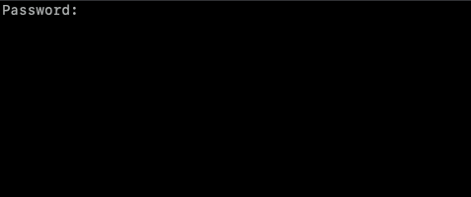

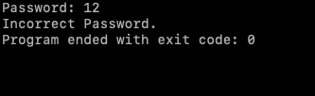

Menu Screen:

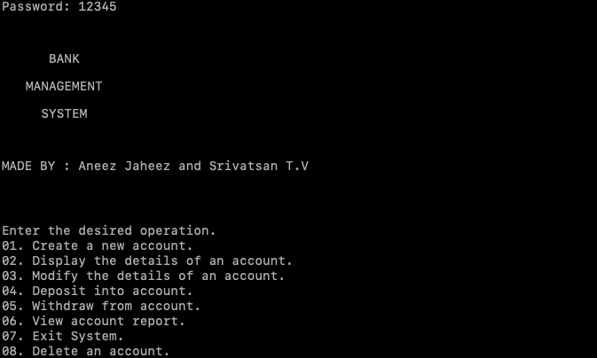

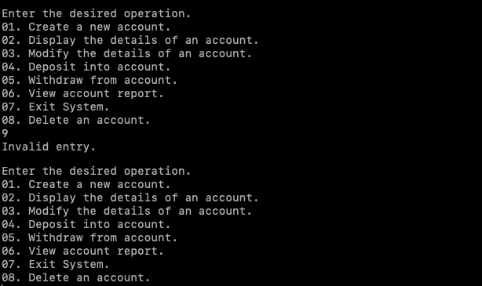

Account Creation:

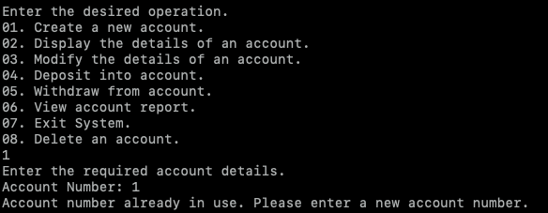

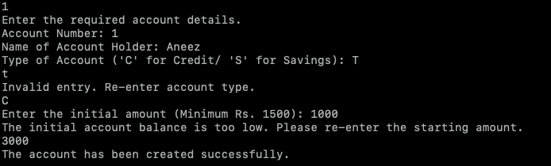

Display Details:

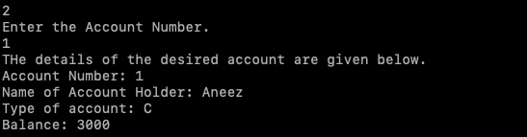

Modify Existing Account:

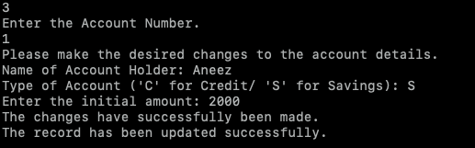

Deposit:

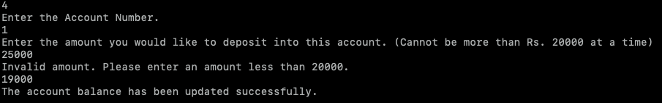

Withdraw:

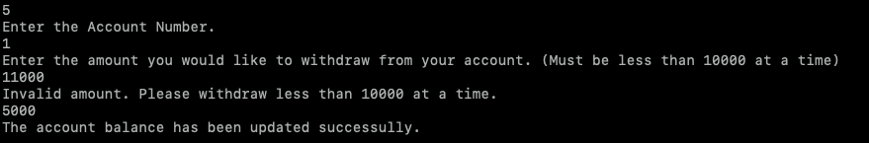

View Account Report:

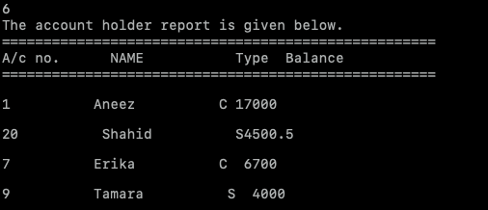

Delete account:

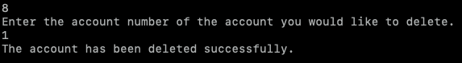

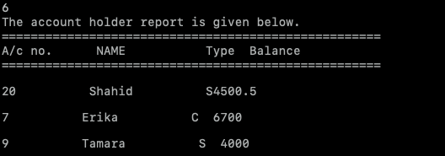

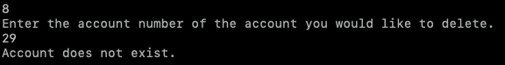

End Session:

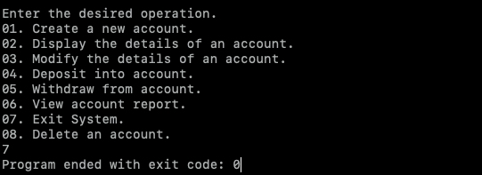

Scope of Improvement:

- It does not provide transactions from one bank to another bank.
- Separate accounts for each bank.
- Transactions only during bank timings.
- Time consumption for performing and recording transactions due to the number of people and processes involved.

Bibliography:

- https://www.ijariit.com/manuscripts/v3i1/V3I1-1233.pdf?04d616&04d616 – An insight into multi-banking systems.

- http://www.fsb.org/wp-content/uploads/P011117.pdf - The use of computer science in financial services.

- http://www.continuitysoftware.com/wp-content/uploads/2013/07/Banking-Case-Study.pdf - A case study on banking services.

- Computer Science with C++ for Class XII - Sumitha Arora (11th Edition)

